YIPPEE! IT’S ENDING!!! After being locked down for months, in Poland, we can now go to restaurants, hotels, church and even hold meetings up to 150 people! We’re moving ahead and it’ll be in time for our CAMPING SEASON!
A Summary of My Thoughts on CORONVIRUS: IT STINKS
I could have gladly done without it, but we know that God is in control and it gave us some new opportunities. So, we are anxious to see how He will use it in the lives of teens this summer!
A SPECIAL SUMMER OPPORTUNITY!
We know that God can use the panic of the last few months to soften hearts of young people & that is our sincere prayer! Please join us in those prayers for the summer along with the needs listed below.

OPPORTUNITIES FOR GREAT BLESSINGS:
There is truly no greater investment opportunity than in the life of a young person. It can yield ETERNAL REWARDS!
Camp Scholarships: 60 teens at $100 each = $6,000 https://give.wol.org/05119C
Camp Crew: 8 teens at $550 each = $4,400 https://give.wol.org/05119C
Bible School Scholarships: $5,000 by August
WOL Poland needs young people trained in the Word of God. Through their teen years we disciple them by assisting in their church youth groups and with leadership training. Beyond that, we have a wonderful Bible Institute in Hungary. The cost for one student is $10,000/year and we are constantly looking to sponsor teens to take advantage of this life-changing year. This Fall, we have a very special young man, named Kris, whom some of you met as we were in the states last year. He has received some discounts from the school and along with money he has saved, he will only come to half of the cost. If you could help with this, it would be a true blessing for decades in the life of this young man and for WOL Poland as he is sure to keep helping us in the future.
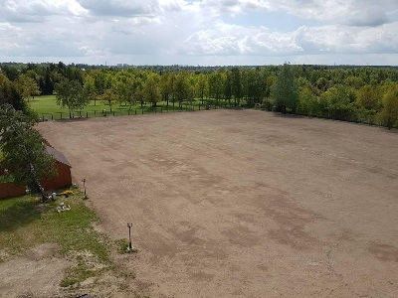
PRAISE & PRAYER
Here you see 2 acres of new sports fields. It took many hours and 7 young people along with myself to rake it all. We are praising the Lord that it’s done and seeded! Now we just need prayer for grass to grow in nicely by the middle of July. PRAY FOR RAIN!

What a joy to write these updates to you! It allows me to reflect on all that God has done and is doing and all He wants to do. Thanks so much for being a part of our team! We truly count it a privilege to be your missionaries to Europe!
Serving Christ,
The Goods, May 2020

